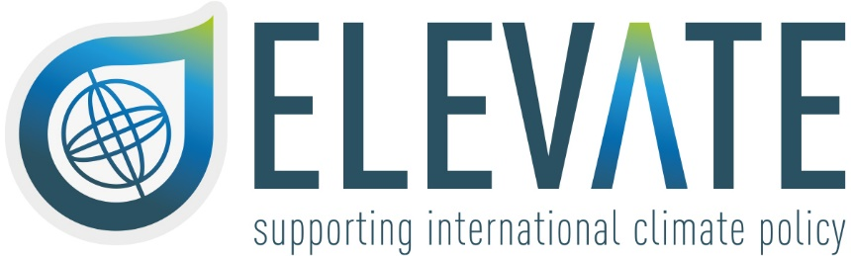

ELEVATE Research Exchange Programme Application Form

The ELEVATE Research Exchange Programme aims at enabling early and mid-career researchers, from within or outside the consortium, to visit one of the ELEVATE partner institutions and have the opportunity to interact with people from different cultural and educational backgrounds. The project offers mobility grants for these abroad visits. Modellers and researchers will share experiences on integrated assessment modelling and the development and assessment of policy-relevant pathways in line with the Paris Agreement goals, as well as evaluating the impacts of different ways to formulate net-zero goals and the impacts of climate uncertainty. Other over-arching issues include climate justice, governance, behavioural changes, and sustainable development.

**Terms: minimum period of 2 months and maximum period of 4 months.**

**\*Mandatory**

**Email address \***

……………………………………………………………………….

**First Name (as per passport) \***

……………………………………………………………………….

**Last Name (as per passport) \***

……………………………………………………………………….

**Date of birth \***

……………………………………………………………………….

**Citizenship \***

……………………………………………………………………….

**Are you affiliated with an institution that is a member of the ELEVATE consortium? \***

YES NO

**Affiliation \***

…………………………………………………………………….

**Position/Job title \***

……………………………………………………………………….

**Research fields or area of study \***

……………………………………………………………………….

**Country of residence \***

……………………………………………………………………….

**Telephone number (including prefix) \***

……………………………………………………………………….

**Exchange Programme – Proposal on Starting and Ending dates (DD/MM/YYYY format) - minimum period of 2 months and maximum period of 4 months. \***

……………………………………………………………………….

**Hosting Institution during the exchange (ELEVATE partner) \***

……………………………………………………………………….

Together with the application form, the applicant is required to send the following documents: (1) CV; (2) Endorsement of the affiliated institution (recommendation letter); (3) Endorsement of the host institution, confirming their availability to welcome the applicant; (4) Plan of the research activities (max 500 words), specifying their relevance for the ELEVATE project. Please combine the documents into one single pdf file. Please send the application via email to the ELEVATE Secretariat ([elevate.secretariat@pbl.nl](mailto:elevate.secretariat@pbl.nl)). *

By sending this form, the undersigned consents to the processing of personal data pursuant art. 13 GDPR 679/16. The information will only be used for the purposes of reporting key participant statistics to the European Commission. The data will be stored securely until the end of the ELEVATE project (31 August 2026). You may withdraw your consent to the use of the data at any time by emailing the ELEVATE Secretariat ([elevate.secretariat@pbl.nl](mailto:elevate.secretariat@pbl.nl)). *

I agree

……………………………………………………………… ………………………………………………………………………

Place, date Signature